**DIGITAL LOGIG DESIGN**

**REPORT**

**Project Name:**

Four Way Traffic System

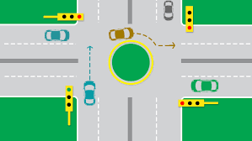

**Group Members:**

* Abdul Ahad Shaikh (20K -0319)
* Mohammad Basil Ali Khan (20K -0477)
* Syed Jodat Ali Naqvi (20K -0155)

**Objective:**

The main objective was to make four way traffic system basic logical IC’s without using any programmable device like Arduino. Four-way traffic lighting system is a signaling device positioned at road intersections, pedestrian crossings and other locations to control flows of traffic. Traffic Lights assign the right way to pedestals by the lights in standard colors; red, yellow and green. Glow of the green light allows traffic to flow in the directions denoted, glow of the yellow light denoting prepare to stop while the glow of the red signal prohibit any traffic from proceeding.

**Research and Project Selection:**

We selected this project as we have seen traffic lights in our daily life routine, as we were curious to know how these work and also to implement what we have studied in our digital logic design course we have selected this four way traffic system project.

**Software:**

The software we used for implementation of this project is Proteus Professional.

**Apparatus:**

1. **555 Timer IC:**

Used to generate clock pulse.

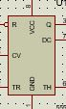

1. **4017 IC:**

The 4017 IC is a CMOS Decade counter and it is used in the applications of low-range counting. This IC will count from 0 to 10.

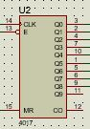

1. **Resistors:**

Used to limit flow of current.



1. **Capacitors:**

Used to store and release electricity in a circuit.



1. **AND Gate:**

|  |  |  |
| --- | --- | --- |
| **A** | **B** | **C** |
| 0 | 0 | 0 |
| 0 | 1 | 0 |
| 1 | 0 | 0 |
| 1 | 1 | 1 |



1. **NOT Gate:**

|  |  |
| --- | --- |
| **A** | **A`** |
| 0 | 1 |
| 1 | 0 |



1. **Wire:**

Provides path for current to flow.



1. **Traffic Lights:**

Used to show illumination of red, yellow and green light.

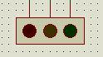

1. **DC Generator Power Supply:**

Used to provides a variable voltage source for DC circuit

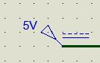

**Design:**

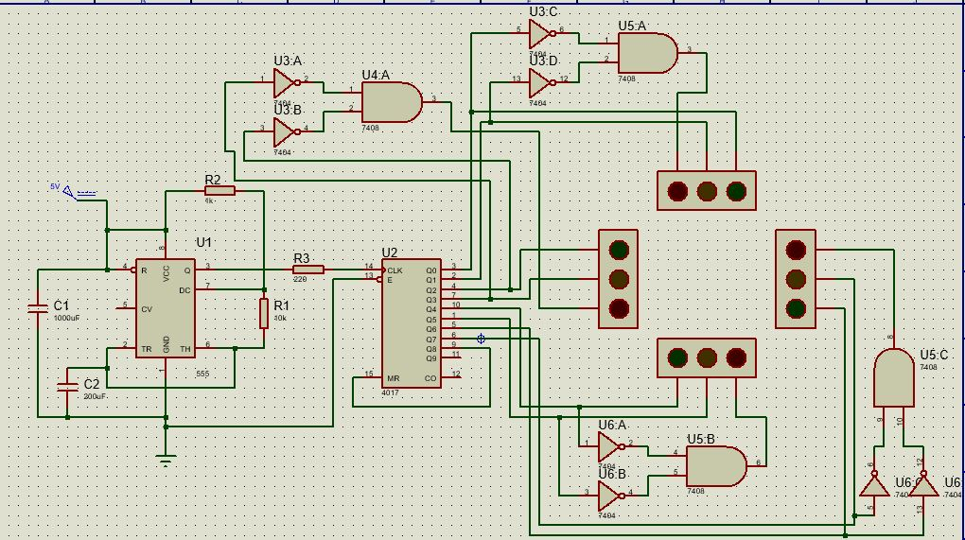

**Explanation of Project**

**555 TIMER IC:**

This IC is used to produce accurate time delays or oscillations or periodic digital signals in a circuit.

Basically it consist of flip flops that are responsible for producing oscillations.

The output of this ic depends on the two inputs, trigger and the thresh hold. Depending on how the inputs are given there are three modes this ic can be used i.e bistable, monostable, and stable mode. Both bistable and monostable mode requires manual shifting of inputs to produce time delays while astable mode make this ic a free running multivibrator. It continuously switches between high and low output without any external trigger. So to produce a continuous timing cycle to switch lights accordingly. We can change the frequency by the capacitors and resistors used before inputs. When current starts to flow through the two resistors and a capacitor ,capacitor will start to store charges on one of its plate which makes threshold high while other plate of the capacitor has less charges thus it will make trigger low. In this condition output of the TIMER IC will be high. And meanwhile the plate with low charges is gaining charges. As soon as this plate get more charges than the other , trigger will be high and the output will be low. Threshold will be low so output will also be low in that case.

**4017 IC DECADE COUNTER:**

Basically this is the counter that counts and switches its output when ever the the clock switches from low to high. It counts in a way that it makes the certain number high like firstly making 0 pin high then on second cycle it makes 1 pin high and so on. Lets suppose firstly 0 pin was high, then if input clock switches to low ther ewill be no change in output but as soon as the clock becomes high again, output will switch to the next number output. This is the way it counts and makes certain condition working. Now we connect the input of clock pin with the output of our timer, via resistor, which produces oscillation. The enable power is connected and has 10 outputs which are further connected to our circuit.

**LED DISPLAY:**

These LED’s are controlled by the clock pulses generated by the outputs of 4017 IC. When Q0 output of 4017 IC is high, it will glow the green LED of the front(top one) signal while Q0 is also connected to the NEGATIVE AND gate logic that receives high from Q0 and low from Q1 so NEGATIVE AND outputs ‘0’ which turns off the yellow LED. Next, when Q1 is high front(top one) yellow led glows while all remains turned off. Similarly after next pulse when Q3 is high, it glows the green LED of next signal, in this condition the previous Q0 and Q1 are low, resulting in producing high output by NEGATIVE AND gate so that it will glow the RED LED of previous signal .In the same way all the RED LEDS keep glowing except the one in which any other LED is glowing.

**OUTPUTS:**

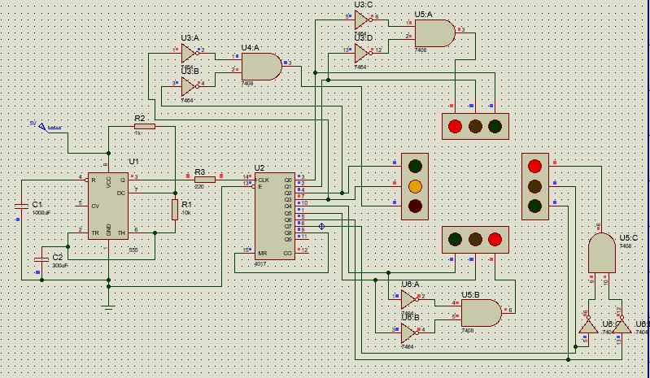

Hence in this case, when Q3 is activated, left signal turns yellow but rest of them are connected to NAND gate, and all outputs other than Q3 are 0 so when NAND is implemented all lights turn to red.

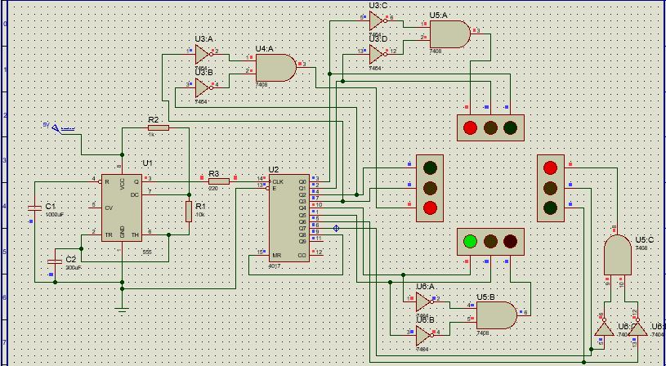

When Q4 is activated, it directly displays green signal. The other lead is connected to NAND gate, so if anyone of them has 0, the overall display will be off for red. Q5 is not turned on yed in the IC that’s why yellow is not displayed yet.

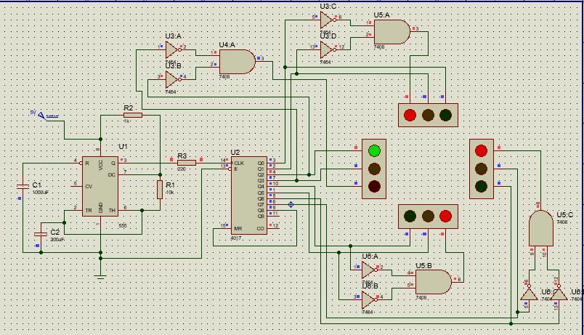

Green light is activated in this case because it is directly connected to Q2. All others are connected to nand gate and hence same condition applies again.